**Project 2: Philosopher Dining Problem**

**Steps to run the program**

1. First of connectthrough university’s server through Putty (using forticlient VPN)
2. After Transferring all the files to the school servers through WinSCP we run our command to putty.
3. **Since we have to connect through different server, I have chosen the servers**

sigma26.bmt.lamar.edu, 140.158.130.213

sigma28.bmt.lamar.edu, 140.158.131.163

Main beta 140.158.130.245

We also need to transfer our program files to all the three servers through WinSCP

1. In putty we have to first run the main server which will be done by following steps.

Go run Main.go 5050

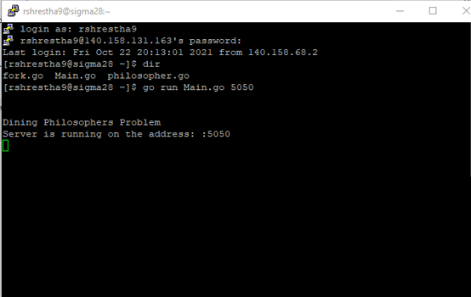

1. After running the main.go , we then open the Philosopher.go on separate server.

Here in this program, I have used address 140.158.131.163 on the main server. We can use any server we like here

Here the program there is total of 5 philosopher and 5 forks. We have to make sure that there are multiple servers otherwise it will give error like the picture below. At first, I ran the program using the same server but it didn’t initiate properly and gave error.

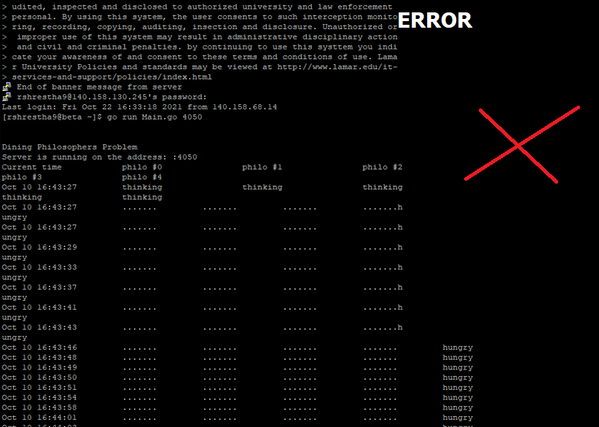

1. We then run the philosopher.go and fork.go on sigma26.bmt.lamar.edu, 140.158.130.213

And Main beta 140.158.130.245

We also connect the folk on the following address

140.158.130.213: 5001

140.158.130.213: 5002

140.158.130.213: 5003

140.158.130.213: 5004

140.158.130.213: 5005

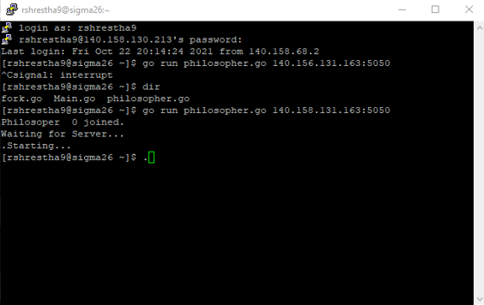

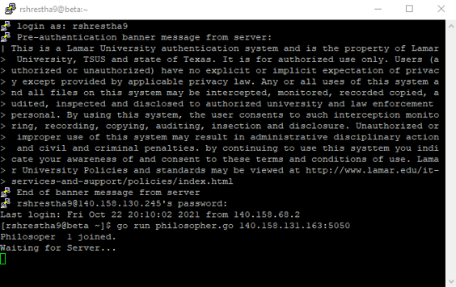

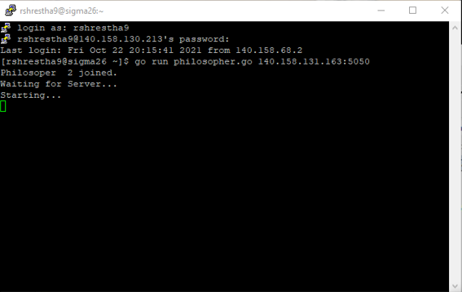

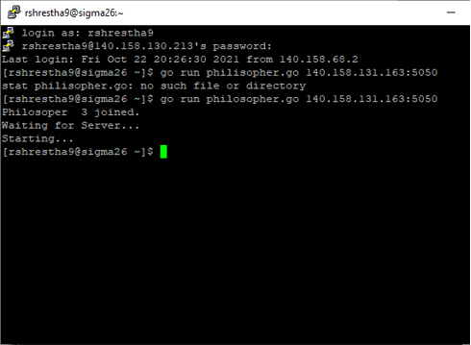

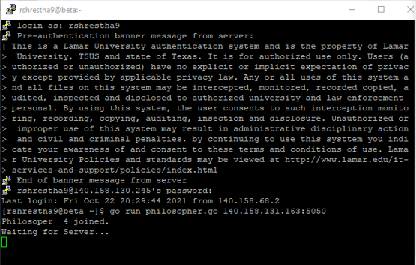

Fork command is initiated on different server by using

go run fork.go 140.158.131.163:5050 140.158.130.213:5001

go run fork.go 140.158.131.163:5050 140.158.130.213:5002

go run fork.go 140.158.131.163:5050 140.158.130.213:5003

go run fork.go 140.158.131.163:5050 140.158.130.213:5004

go run fork.go 140.158.131.163:5050 140.158.130.213:5005

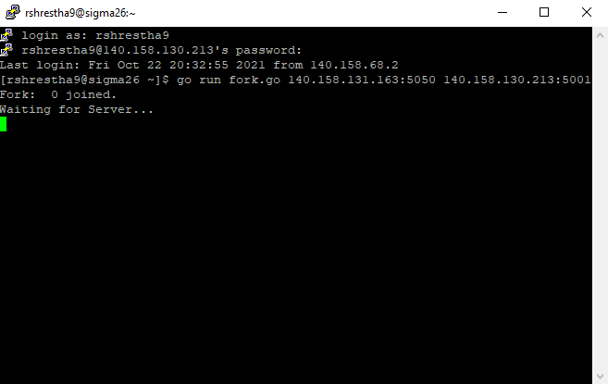

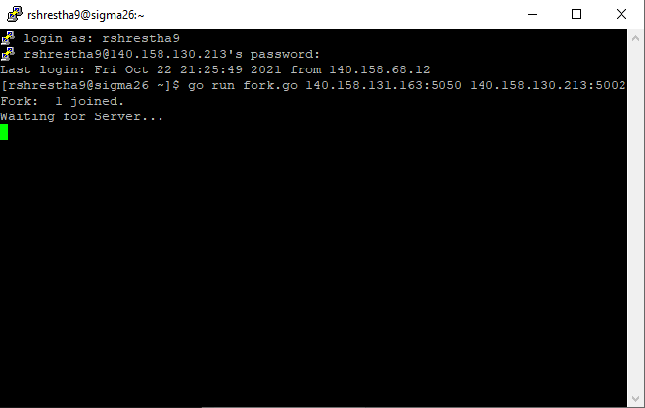

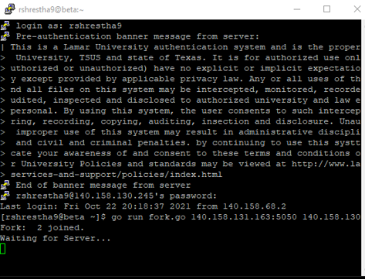

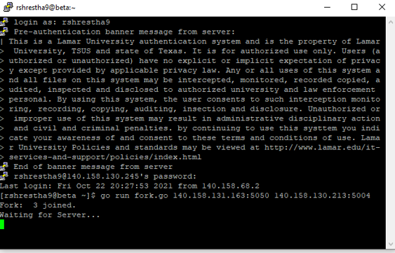

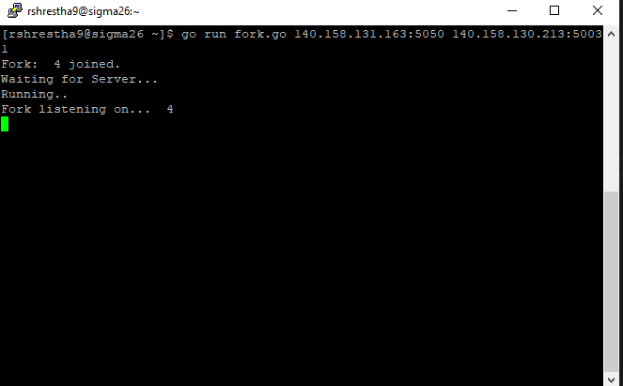

1. After running the program, we can see the output on the window where we ran the main.go

